Pacing Proportions

ABSTRACT
The purpose of this lesson plan is to help my students to use prior knowledge, and unusual materials to make measurements and test for accuracy. Students of all ability levels can use logical reasoning to help solve everyday problems, and if the problem is phased in such a way as to keep them from not being intimidated. This can help them to develop these reasoning skills that are necessary for math, science and life in general.

I conducted the lesson plan with three 7th grade math classrooms of varying ability. The students are first given a pre-test at the beginning of a 97 minute block of class time to assess prior knowledge. They are then given some questioning prompts to develop an interest in the problem to be solved. The students are placed in groups of four; develop team names, and methods to solve the problems. The students are taken outside to follow their procedure to figure out distance around the track. After students have deliberated and decided on an answer students are taken inside for classroom discussion, and to give ideas on how to check their answers.
I found that the students were fully engaged in this activity. I took note that the lowest ability range felt they could have success or contribute to the group, because all students felt equally unable to come up with definitive answers for this activity. The brainstorming was very impressive for students at this age. I was surprised by their willingness to listen to each other, and to determine whether or not a plan was feasible.

Grade Level
5th -8th grade

Resource Type

Field activity

Subject

Math

National Math Standards

Grade Level Expectation: Number sense: 6-8
- Work flexibly with fractions, decimals, and percents to solve problems
- Understand and use ratios and proportions to represent quantitative relationships

Grade Level Expectation: Measurement: 3-5
- Understand that measurements are approximations and how differences in units
affect precision.

Ohio Math Standards Benchmark Ohio/ Number Sense
- Use a variety of strategies, including proportional reasoning, to estimate, compute, solve and explain solutions to problems involving integers, fractions, decimals and percents.

Ohio 7th grade Indicators

Number and Number sense:
7.1- 8. Develop and analyze algorithms for computing with percents and integers, and demonstrate fluency in their use.

Measurement:
7.2-3. Estimate a measurement to a greater degree of precision than the tool provides.

7.2-4Solve problems involving proportional relationships and scale factors; e.g., scale models that require unit conversions within the same measurement system.

7.2-5 Analyze problem situations involving measurement concepts, select appropriate strategies, and use an organized approach to solve narrative and increasingly complex problems.

Your Local Course of Study Objectives
Our Mission Statement
The mission of the Scioto Valley Local School District is to provide all students with the knowledge and skills to prosper socially, emotionally, and morally in order to be productive members of their community, nation, and world.
Our Vision Statement
Within the next ten years, we will develop a functional educational community by providing each student with a safe and positive learning environment to develop the potential of all students.

Your OBJECTIVE(S)

Students should be able to:
- Apply prior knowledge to real-life problem situations.
- Demonstrate knowledge of simple measurement.
- Create a plan to successfully estimate a difficult measurement.
- Analyze data collected in an experiment.
- Evaluate an estimate to determine accuracy.
- Compare answer found to the actual answer.
- Justify the answer you found, and discuss possible mistakes.

ACTIVITY PRE-ASSESSMENT

See attachment A

Your Lesson/Project
Materials Needed:
- String, rope or caution tape cut to length of your choice. ( I used nine feet)
- Tape measure
- High school track with good weather
- Attached documents
- Clipboards(optional)
- Teacher passes out pre-assessment and allows the students time to finish.
- When students have completed the assignment, teacher begins discussing possible options for measuring long distances. Possible questions:
  - What did people in ancient history use to measure?
  - What did people do before surveying equipment was available?
  - What did people do before accurate maps and Google Earth?
- Teacher demonstrates a proper techniques for recording a pace ( start on left end on right)
- Teacher paces off classroom.
- Students and teacher begin to discuss what they think are the dimensions of the floor tiles. Possible questions:
  - How do we know the dimensions?
  - How could we use the knowledge of 1 ft floor tiles to solve the actual distance of the room?
  - Are there other measurements that we are aware of in everyday things?
- Teacher asks, “How can I find the length of just one of my paces?”
- Students and teacher discuss uses of proportions if no one suggests them.
- Students are broken into groups of four.
- Students are taken outside to high school track.
- Each group is given a length of string. ( Do not tell them the actual length…some figure it out on their own)
- Students are to follow the steps on the lab sheet to find the length of their personal pace.
- The students must pace off the length around the high school track. I walk with them.
- Give the students specific instructions for pacing the track.
  - They must end in the exact place they start.
  - They need to stay in the lane they begin in.
  - Count in your head.
  - You can use a finger to hold you place after you reach 100 (ex. 1 finger = 100, 2 finger = 200…)
  - Be as specific as possible.
- When students have their number (it should be over 300) the students can return to class to finish analyzing the data they have collected.
- Students in groups figure out their estimates for the length of the track, and discuss amongst themselves how accurate they think this is.
- Students come to an agreement on how long they think the track is as a group.
- Chart data on board.
- Discuss ways they could get a more accurate answer.
  - Try experiment more than once.
  - Compare with others.
  - Find the average of the groups estimates.
- Teacher discusses with the class how they could check the answer. Answers will vary. (The actual length around a standard quarter mile track is 1320 ft.)
  - Google Earth.
  - Ask the track coach.
  - Have the area surveyed.
  - Tie together many lengths of rope, and stretch around the track (actual student answer)
- Discuss the possible errors that could be made.
  - Inside or outside of track?
  - Did they lose count?
  - Did they go faster at the beginning?
  - Were their paces uniform?
  - Did they change lanes?
- Take post-assessment.

PRE/POST-ASSESSMENT

Lab Sheet- See Attachment B
Post Assessment- See Attachment C

Attachment A

Pacing Pre-Test 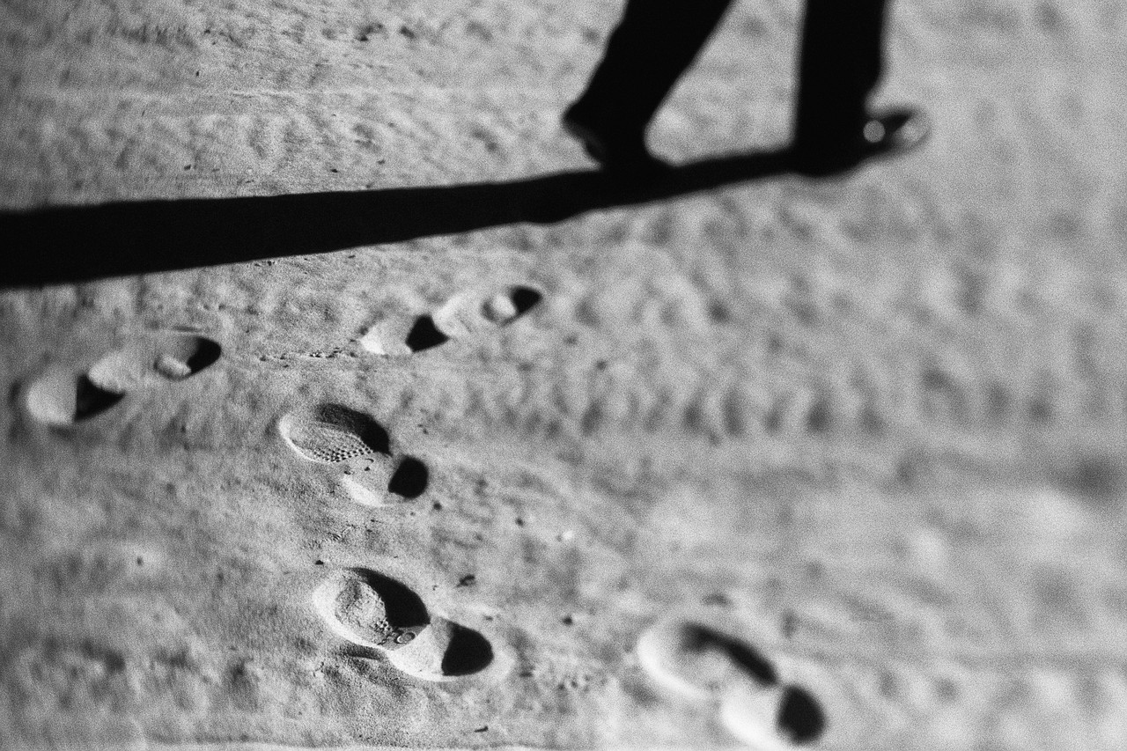

Name___________________________Date____________

- One of my paces is equal to____________ft.

- It takes _________________of my paces to equal 1 ft.

- How many paces would it take to go around the track?

- A standard high school track is ________________ft long.

- How can we measure a long distance without a measuring device?

- How could we check for accuracy?

Attachment B

Pacing Proportions

Team name_______________________________

- It takes me ___________________pace to reach the end of the mark.

- The linear measure of this is ____________________ft.

- Written as a proportion _______________paces
ft
- Divide it out=

- Over one foot= ____________
1 ft

- It took me _______________paces to go around the track.

- Set up as a proportion: _______________paces=______________paces
Ft ft

- Cross multiply and solve for the missing linear ft measure.

- How close do you think your estimate is?

- How could we check our answers?

Attachment C

Pacing Post-Test

Name___________________________Date____________

- One of my paces is equal to____________ft.
- It takes _________________of my paces to equal 1 ft.
- How many paces would it take to go around the track?
- A standard high school track is ________________ft long.
- How can we measure a long distance without a measuring device?

- How could we check for accuracy?

